’ TONY BLAI R
I N ST IT UT E
-

FOR GLOBAL
C HA i i G £

TRAINING NOMINATION FORM

Public Sector Digital Skills, Culture and Leadership for Digital and Tech Transformation

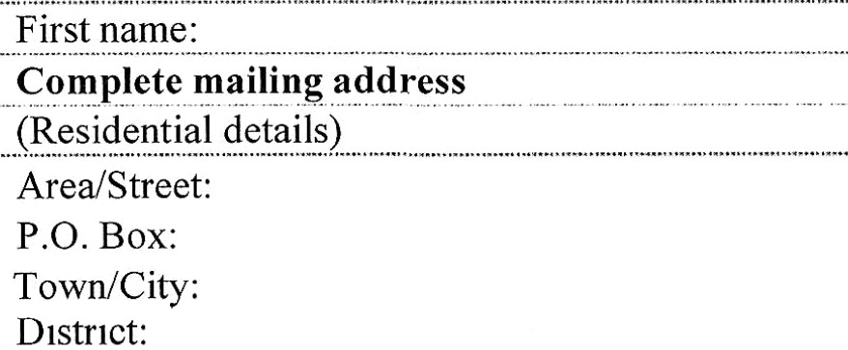Work Details
Male
Female
Family name:
(as on National ID)
Personal Information
Desig. n.at.i.on. : .
Ministry:
.
Department: . Grade:
:
Em. ail A.. .d. dr.e.ss:.
Phone number:

Level: Junior to middle management
Technical lead
Senior leadership

EDUCATION (Commencing with tertiary)
Name and place of institution | Field of study | Diploma or degree
YOUR CURRENT ROLE AND DESCRIPTION OF DUTIES
HAVE YOU EVER WORKED ON DIGITAL PROJECTS/ DIGITAL TRANSFORMATION? (Please describe)
LIST KEY ICT TOOLS RELATED TO YOUR WORK THAT YOU USE

